W300D(v5.0)-How to setup wireless router mode?

Product line: ADSL
Question category: wireless settings

I. Physical connection:

1. Connect your modem to the NO.4 yellow port the default WAN port, then connect your computer to one of the other 3 yellow ports.

2. Check the LED lights. Making sure Power is on, the LAN port which you have plugged the cable in is on, the SYS and DSL are blinking.WLAN is on or blinking.

II. Login to the management page of the router:

1. Open a web browser (IE, Firefox, Safari, etc.) and find the address bar, leaving it blank before typing in 192.168.1.1, and then press enter.
(Care: The address bar is in the most top of the web page after opening web browser).

2. You will see Tenda Login page.
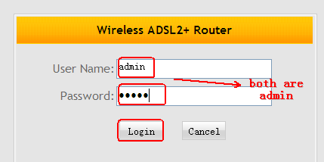
3. In the following page please click Advanced.

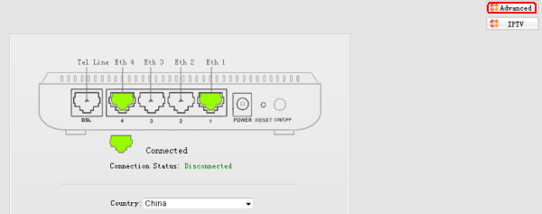

4. In the following page, please choose Wireless routing, then click Next.
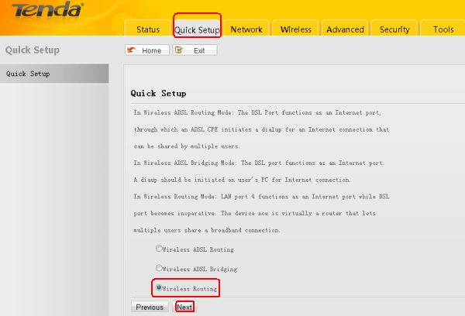

5. Choose your Internet Connection Type, then click Next.
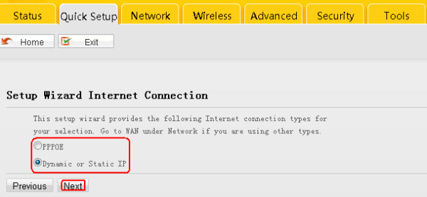
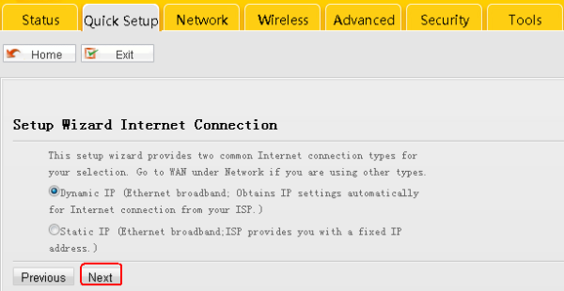

6. Set a name for your WiFi by changing SSID and set a wireless password in the blank of Security Key.
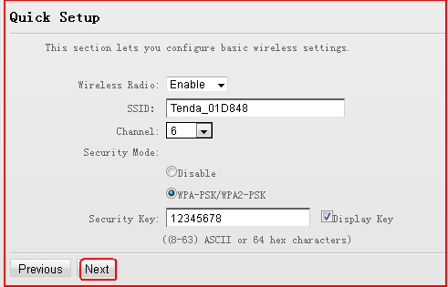

7. Click Save to finish the settings, after rebooting, check the status of WAN, if the Connection Status shows Connected, you can access internet.
